**The Interface Design Documentation of EPC**

1. **Introduction**
   1. **Design Instruction**

EPC is a simple and clear system with a beautiful interface. Its interface style is chosen to be simple and easy to operate, and it uses element component library for implementation.

* 1. **User Assumptions**

1. Financial managers: provide clients with investment history recurrence services and comparative recurrence services to facilitate the marketing of fund products
2. Individual investors: get portfolio recommendations, and can view the history of a certain period of time portfolio recommendations record
3. Bank analysts: obtain portfolio record details
4. **Interface Design**
5. **Login Screen**

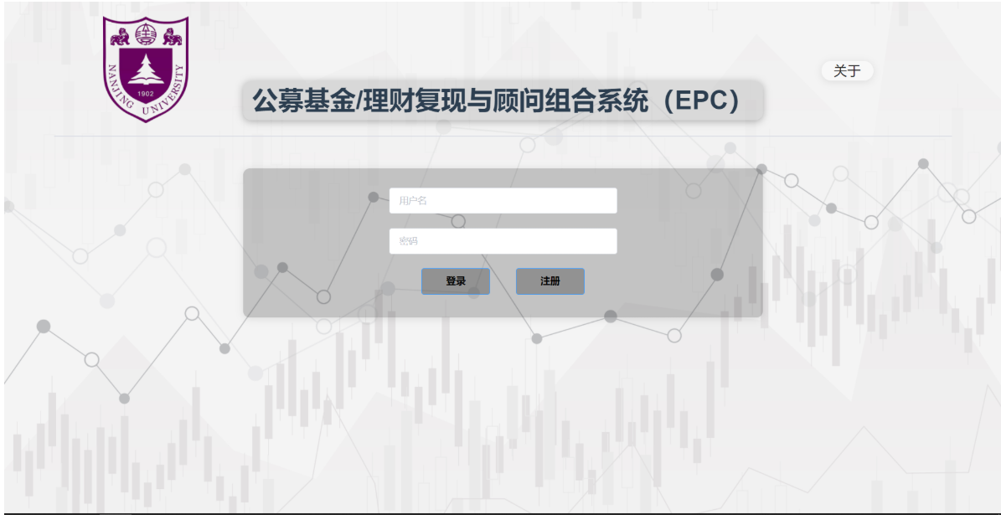

**2. Character-choosing Screen**

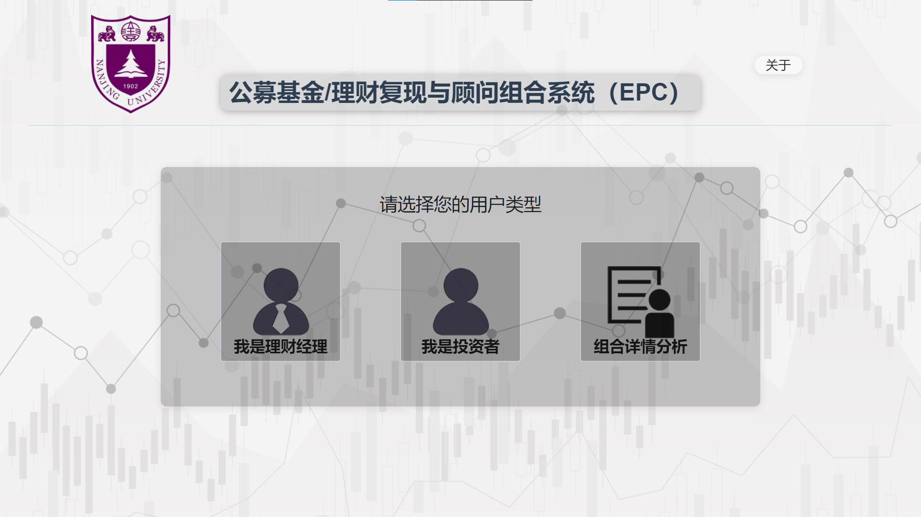

**3. Records-uploading Screen for Financial Manager**

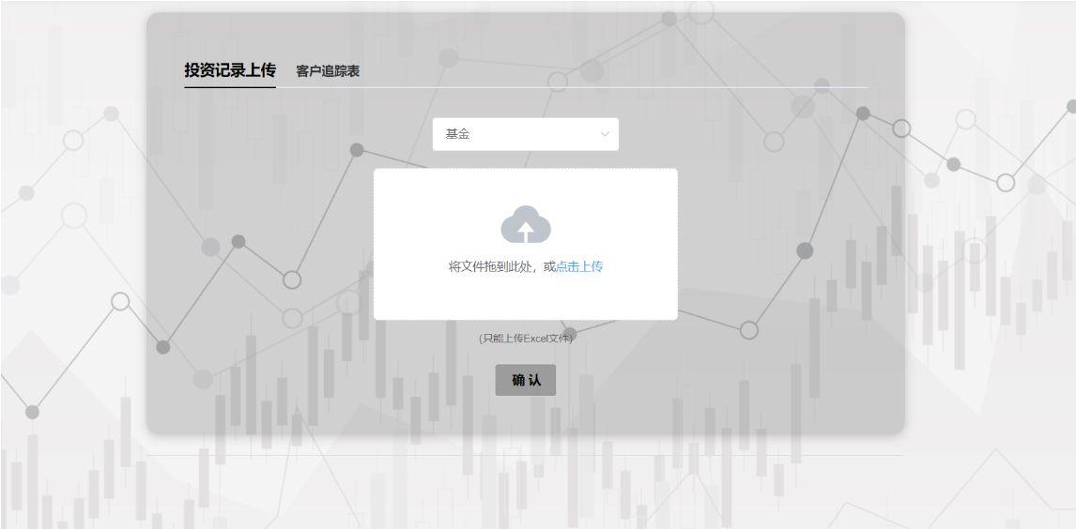

**4. Investment history recapture Screen**

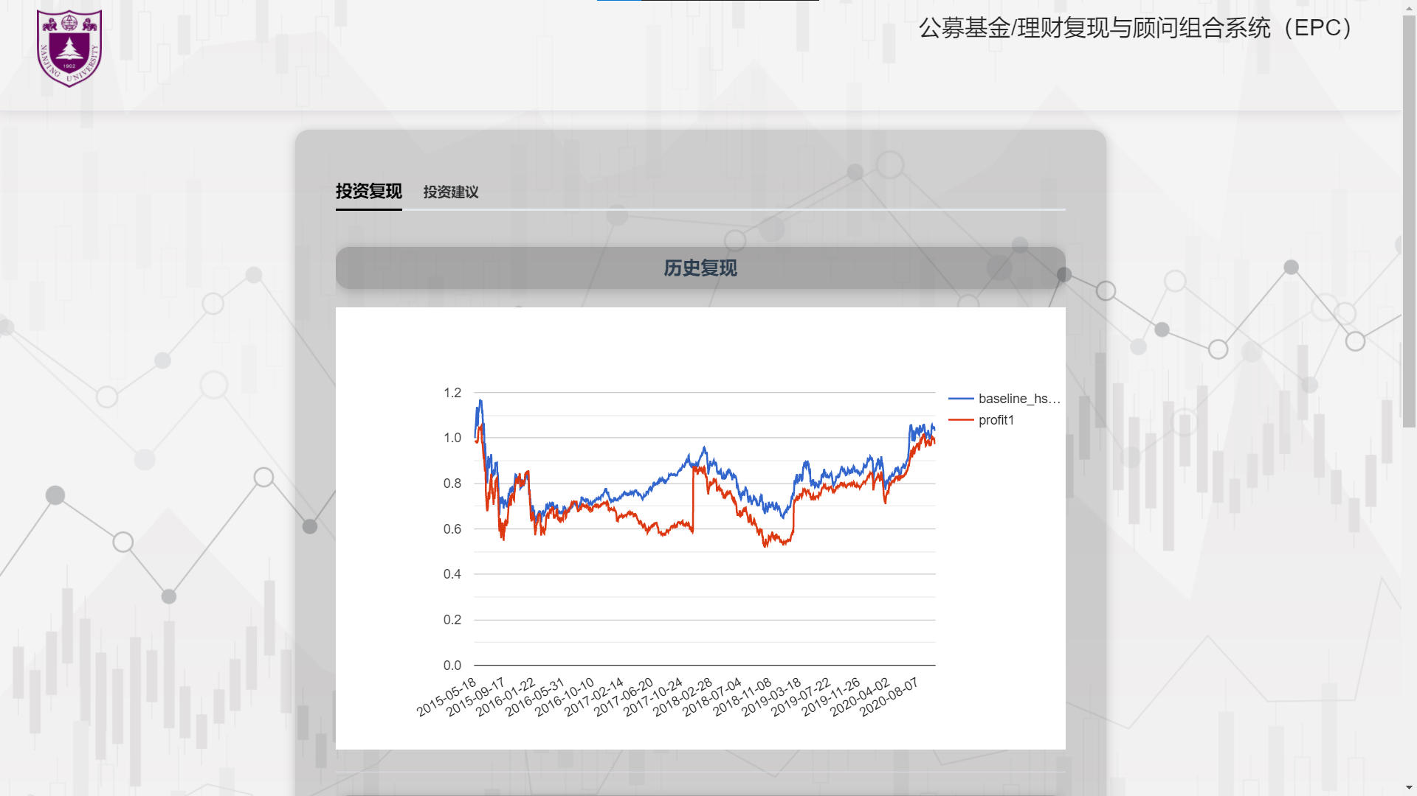

**5. Contrast reproduction Screen**

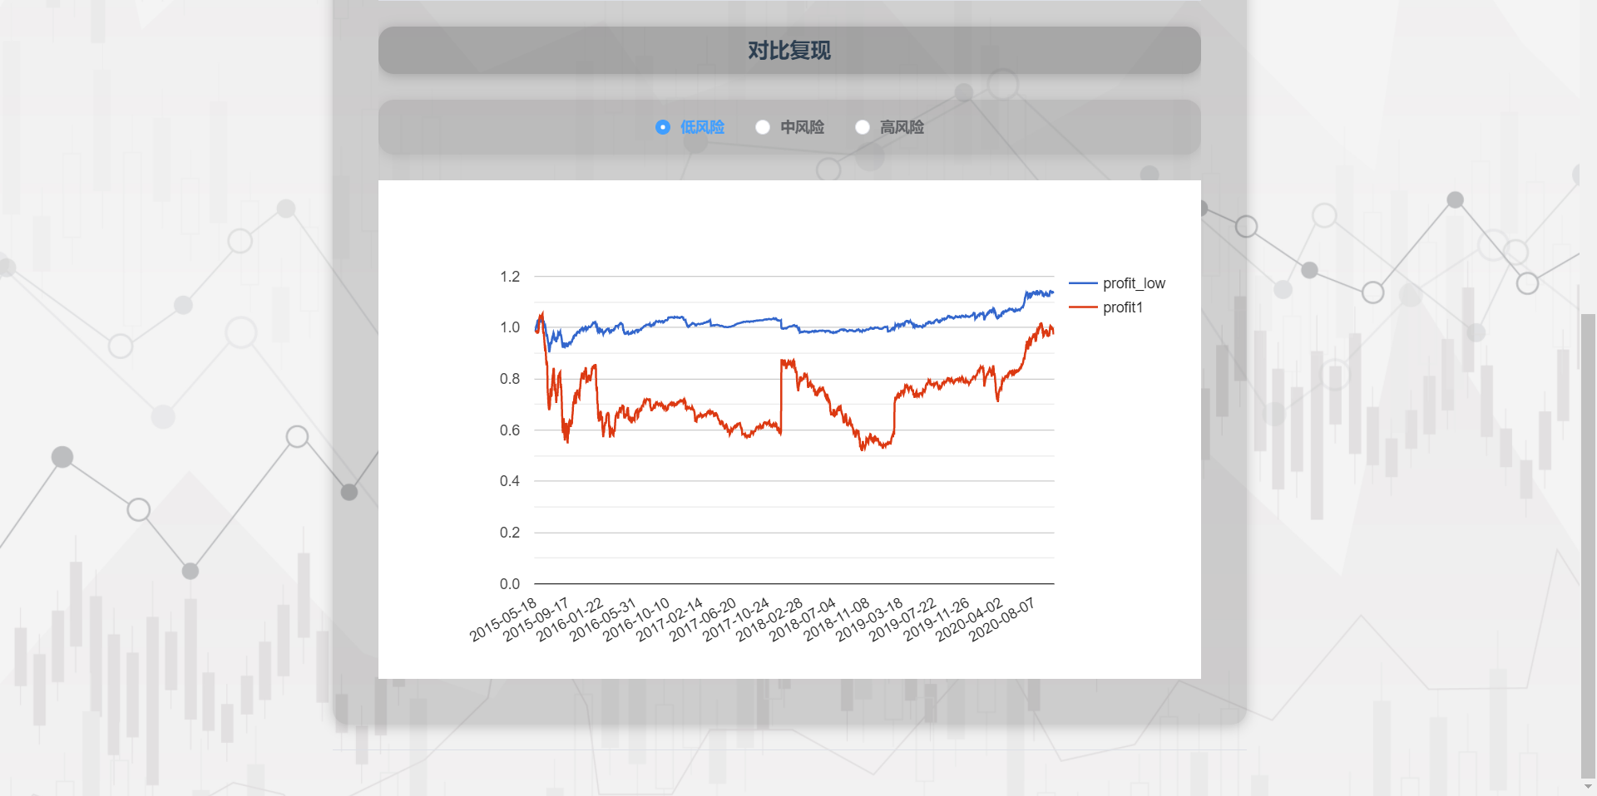

**6. Portfolio recommendation Screen**

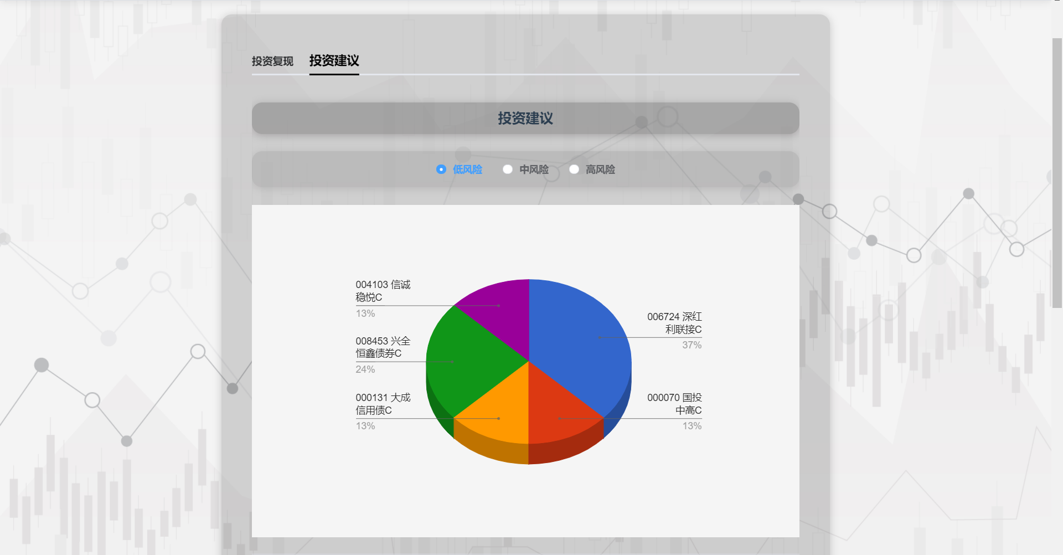

**7. Historical Portfolio View Screen**

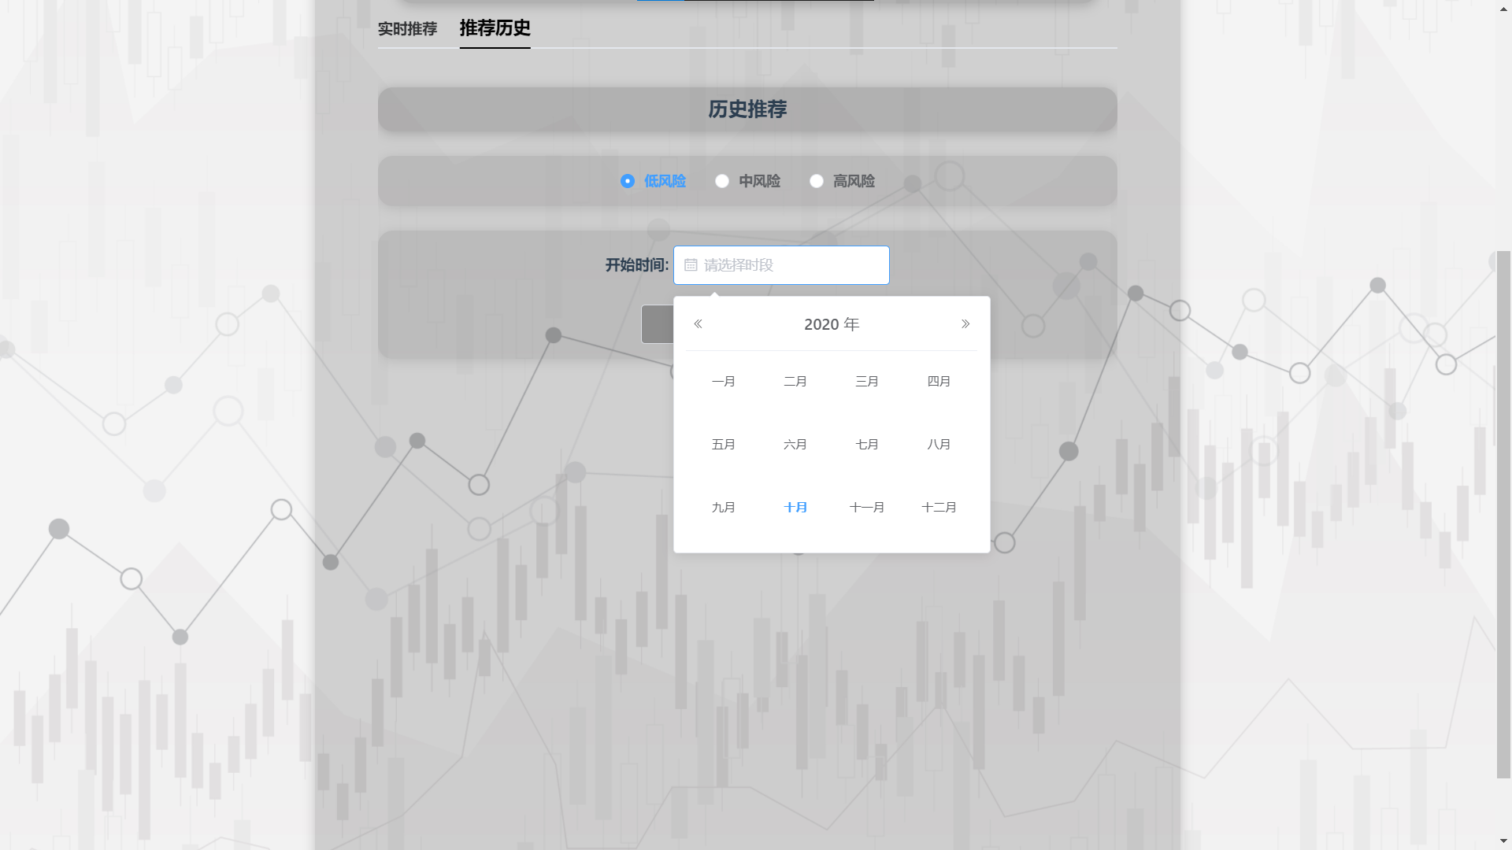

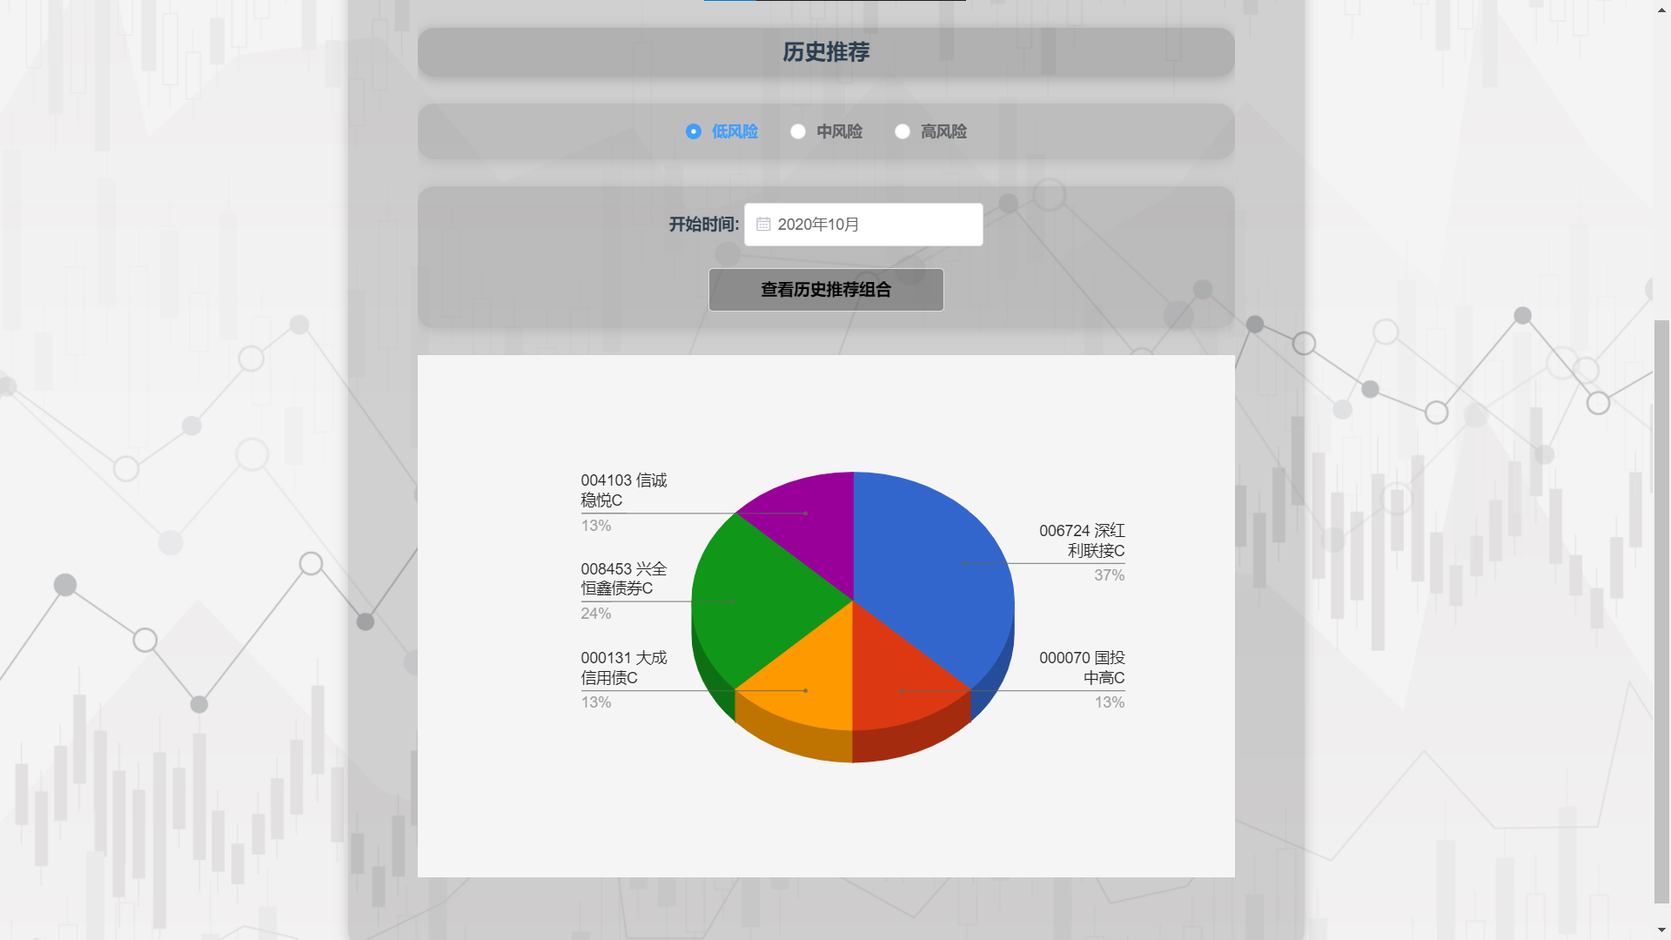

**8. Portfolio recommendation Screen for Individual Investors**

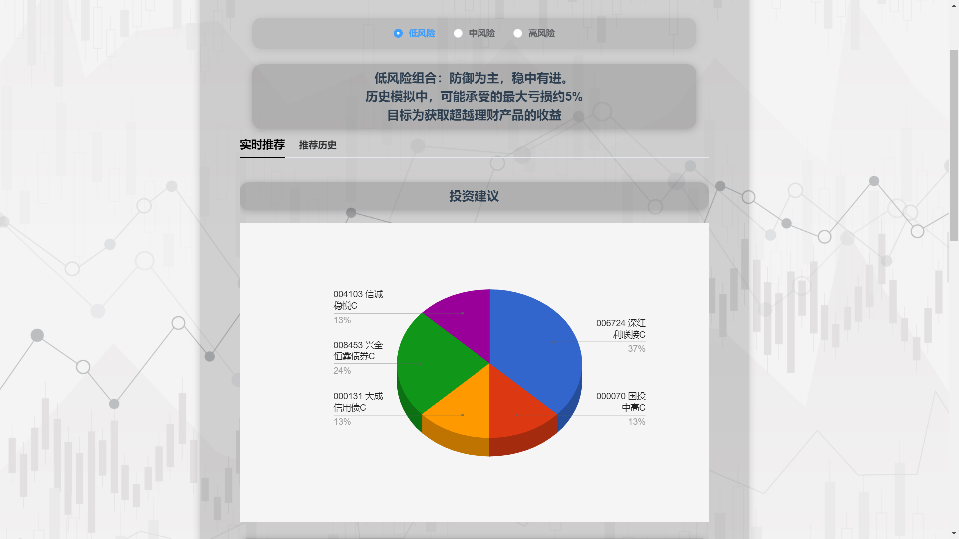

**9. Historical Portfolio Screen**





**10. Analyst Screen (Navigate to new tab pdf file content)**

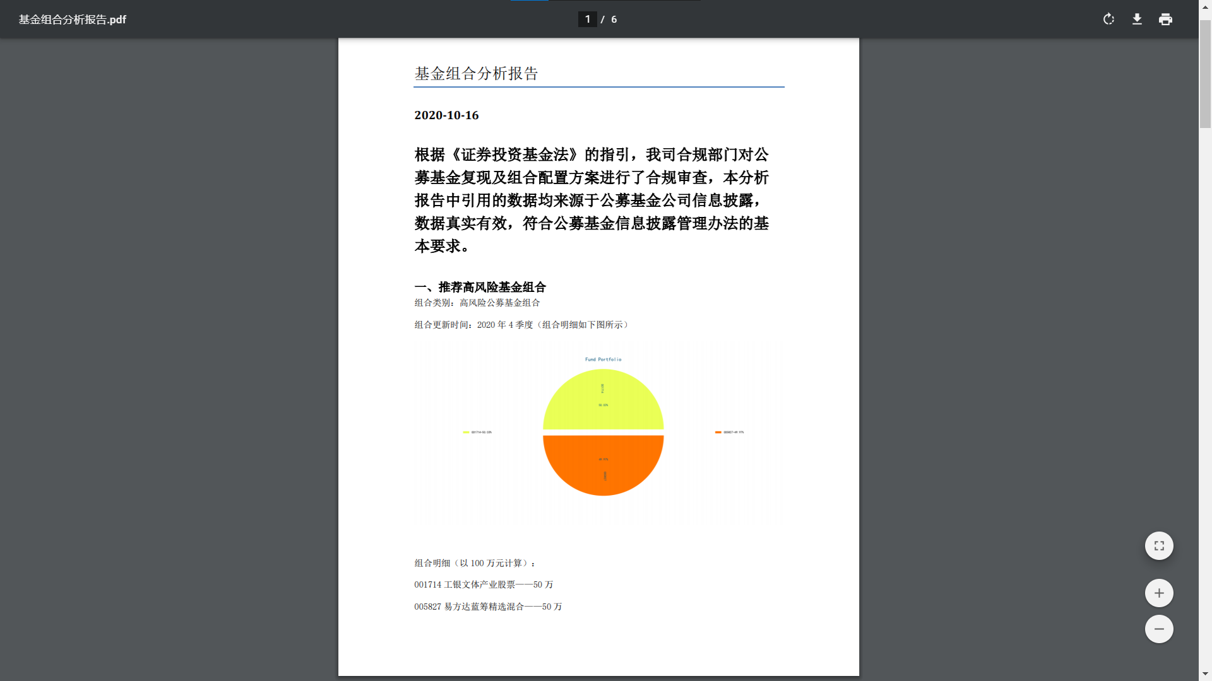

**11. User Tracking Form Screen for Financial Managers**

